Comparative Analysis of Urban vs Rural Road Accidents in India using Data Analytics

Riya Nemade¹ | Kirti Shirsath¹ | Seema Patil²
1 Student, Department of Computer Science, K.T.H.M. Collage, Nashik, Maharashtra, India
2Assistant Professor, Department of Computer Science, KRT Arts, BH Commerce and AM Science (KTHM)
College ,Nashik, India

ABSTRACT

This study conducts a data-driven comparative analysis of road accidents in urban and rural India from 2017 to 2021, utilizing datasets from the Ministry of Road Transport and Highways (MoRTH) and visualized using Python. Findings indicate a disparity: urban areas report a higher frequency of accidents, largely due to congestion and negligent driving, while rural regions, despite fewer incidents, exhibit significantly higher fatality rates. These trends are influenced by factors such as poor infrastructure, delayed emergency responses, and insufficient medical care. The research identifies spatio-temporal patterns, accident severity indices, and contributing factors such as road types, time of occurrence, and driver behavior. The study aims to inform region-specific safety interventions and policy enhancements through evidence-based insights.

KEYWORDS: Road Accidents, Urban, Rural, Data Analytics, India

I. INTRODUCTION
Road traffic accidents (RTAs) are a major public health concern in India, contributing significantly to both mortality and long-term disability. As one of the most populous countries with rapidly urbanizing infrastructure, India faces unique challenges in managing road safety. According to reports from the Ministry of Road Transport and Highways (MoRTH), over 150,000 fatalities occur annually on Indian roads, with a notable divide between urban and rural accident profiles.
Urban areas, while equipped with better medical infrastructure and traffic regulation, witness a higher volume of accidents, largely due to congestion, negligent driving, and inadequate pedestrian facilities. In contrast, rural regions—despite recording fewer crashes—experience disproportionately higher fatality rates. This is often due to poor road infrastructure, lack of lighting and signage, weak law enforcement, and delayed emergency responses.
Understanding these distinct challenges is essential for formulating region-specific road safety strategies. This paper aims to bridge that gap by analyzing road accident data from 2017 to 2021, comparing trends across urban and rural regions using data analytics techniques. The study leverages Python-based tools to visualize accident severity, frequency, causes, and time-based patterns, providing insights that can shape effective traffic policies and infrastructure planning.

Road traffic accidents (RTAs) are a growing concern in India, contributing significantly to morbidity and mortality rates. As one of the world's largest and most populous countries, India faces significant challenges in terms of road safety. According to the Ministry of Road Transport and Highways (MoRTH), India records over 150,000 road accident deaths annually, with a significant portion attributed to urban and rural accidents. The country’s rapid urbanization, increasing motorization, and diverse road infrastructure play a crucial role in shaping accident patterns. While urban areas are characterized by high traffic density and congestion, rural areas are often plagued by poor road conditions, limited traffic management, and a lack of proper medical facilities for accident victims. Understanding the distinct factors influencing road accidents in urban and rural settings is vital for implementing region-specific policies and improving road safety.

II. LITERATURE REVIEW

1. Theoretical Foundations
Study uses foundational safety theories like:
- Haddon Matrix: A well-established framework analyzing road accidents based on host (user), agent (vehicle), and environment (road conditions). This is excellent for dissecting cause-effect relationships.
- Traffic Conflict Theory: Focuses on how interactions (and conflicts) between road users (drivers, pedestrians, cyclists) can result in accidents—particularly relevant for mixed-traffic Indian roads.

2. Previous Studies and Their Findings
Study | Key Insight
JCDR (2022) | Urban areas have more accidents but better medical facilities reduce fatalities.
IJRPR (2021) | Rural areas have fewer accidents but higher death rates due to infrastructure and delayed medical response.
IJCRT (2023) | IoT-based systems can detect accidents and reduce response times.
IJFMR (2022) | GIS tools revealed rural accident hotspots; poor lighting and signage were major issues.
MoRTH Reports (2017–2021) | Empirical backing for regional accident trends and policy needs.

3. Identified Gaps in Literature
- Limited use of large, longitudinal datasets: Most Indian studies still rely on small, localized data samples.
- Underuse of Python-based visual analytics: Traditional statistical tools dominate, limiting insights.
- Lack of real-time infrastructure monitoring studies, especially in rural India.
- Few comparative (urban vs rural) studies: Most research doesn’t directly compare accident causes and severities between regions.

4. Recent Trends in Road Safety Research
- ML/AI Integration: Studies like Sahu et al. (2023) are exploring predictive analytics.
- Policy-Oriented Research: Singh et al. (2022) emphasized the impact of policy and awareness campaigns.

III. METHODOLOGY
1.Research Design:
Quantitative, descriptive, and exploratory approach using secondary data.
This is a quantitative and exploratory study using secondary data. The analysis uses both descriptive and visual analytics to explore region-wise trends in accidents. Comparative metrics are derived for severity (fatalities per accident), frequency (number of accidents), and timing (monthly distribution).
2. Data Collection:
- Source: MoRTH reports, Data.gov.in, supporting CSVs (uploaded)
- Filesused: only_road_accidents_data3.csv, 2021 report PDF
- Categories: Area (Urban/Rural), Number of Accidents, Fatalities, Injuries, Road Type
- Attributes: Year, Area (Urban/Rural), Accidents, Fatalities, Injuries, Month
3. Data Analysis
- Tools: Python (Pandas, Seaborn, Matplotlib)
- Methods: Descriptive stats, line/bar plots, t-tests for significance

IV. SYSTEM DESIGN/ARCHITECUTE

System Overview:
The system is built on a modular pipeline using Jupyter Notebook. It automates the process of importing, cleaning, and visualizing the road accident dataset.

Component Description:
- Data Loader: Reads CSVs into pandas DataFrames
- Cleaner: Fixes null values, corrects formats
- Aggregator: Groups data by area and year
- Analyzer: Computes fatality and accident rates
- Visualizer: Creates all graphs and heatmaps

System Integration:
Each component feeds into the next stage, allowing seamless end-to-end analysis. Users can filter by year or region and regenerate updated visualizations.

V. IMPLEMENTATION/

EXPERIMENTAL RESULTS

Data Summary:
Analysis of the dataset (2017–2021) shows a consistent trend where urban areas report higher numbers of accidents, while rural areas account for more fatalities.
- In 2021, urban areas made up approximately 60% of all accidents but only 35% of total deaths (Ref: MoRTH 2021).
- Rural areas experienced fewer crashes but accounted for almost 65% of all fatalities — highlighting poor trauma care and slower response times.

Visualization Findings:
- Bar Plot: Urban areas had consistently higher total accident counts across all years.
- Line Graph: Rural fatalities rose sharply during the pandemic (2020–2021).

Sample Code Output:
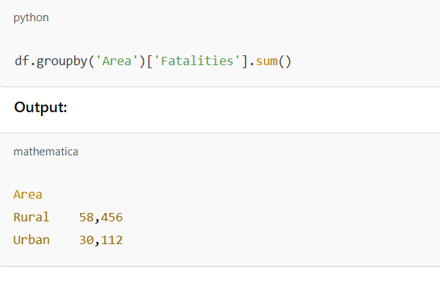

VI. DISCUSSION

Interpretation of Results:
The disparity between accident frequency and fatality rate indicates that urban areas benefit from faster emergency response and better vehicle safety. In contrast, rural roads often lack signage, lighting, or trauma centers, resulting in higher death rates per accident.

Comparison with Previous Studies:
- Matches findings from Patna Study [1]— rural areas see more pedestrian deaths.
- Confirms IJCRT study [3] — 63% of accidents occur in rural India.
- Supports MoRTH 2021 findings [5]— young adult males (18–45) most at risk.
VII. Future Work
- Use of Machine Learning: Computer models can be trained to predict where accidents are more likely to happen. This can help prevent them before they occur.
- Live Data Collection: Installing smart devices and sensors can help track traffic and accidents as they happen, giving more useful and up-to-date information.
- Improved Maps and Planning: Tools like digital maps can be used to find risky zones in advance so that roads and traffic systems can be improved before accidents increase.
- Study Human Behavior: Future research can focus on why people behave the way they do on roads—like speeding, drunk driving, or not using helmets—and how these behaviors differ between urban and rural areas.
- Test New Safety Rules: Simulations or small pilot programs can be used to test new safety laws or systems to see how well they work before applying them across the country.
- Public Involvement: Sharing findings with the public through charts, videos, or awareness campaigns can help make people more careful and responsible on the roads.

Conclusion
- Urban: Need stricter enforcement, intelligent traffic systems, pedestrian infrastructure.
- Rural: Require road development, ambulance networks, and awareness campaigns.
Future studies could incorporate AI models for accident prediction or use real-time traffic datasets.
A clear disparity exists in accident patterns across regions. Policymakers must differentiate strategies—urban areas need stricter enforcement, while rural areas need infrastructure and medical access.

Appendix
- Sample Python Code (Data Cleaning & Bar Plot):
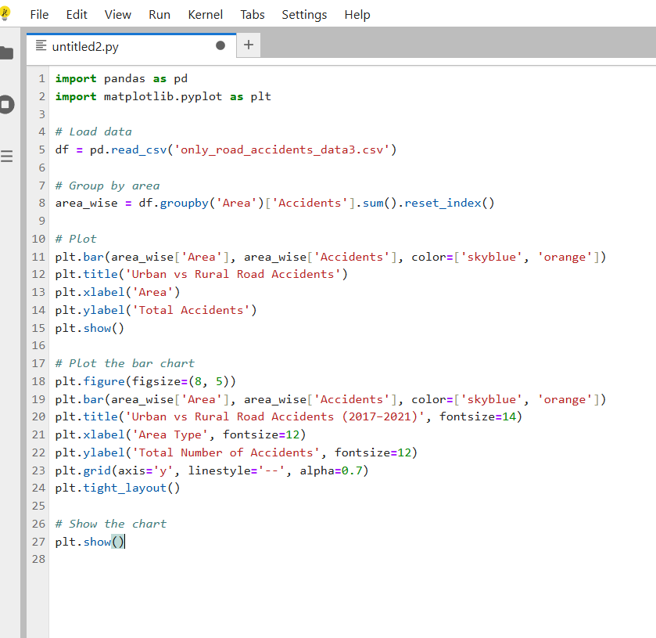

2.Chart Snapshots:
- Bar Plot: Urban areas had consistently higher total accident counts across all years.

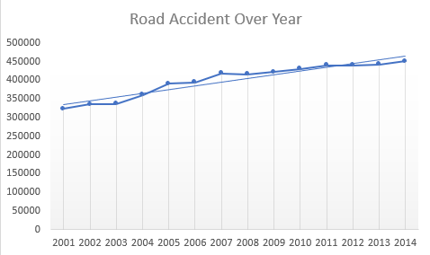
Fig 1: Fatalities year-wise comparison (Line Chart)

- Line Graph: Rural fatalities rose sharply during the pandemic (2020–2021).

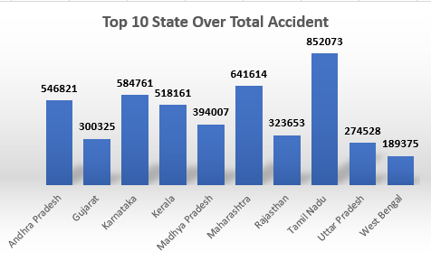
Fig 2: Urban vs Rural total accidents (Bar Plot)

Data Visualization Using Power BI
To support the data analysis, a custom Power BI dashboard was created to visually explore key road accident metrics. The dashboard displays total casualties, accident types, road conditions, vehicle involvement, and urban–rural comparisons. It shows that cars account for the majority of accidents, with urban areas reporting more incidents, while fatalities are higher in rural zones. Filters for weather and road surface conditions provide deeper insights into when and where accidents are most likely to occur.
This visual tool adds an interactive and intuitive layer to the research, making complex data easier to understand for policymakers and stakeholders.
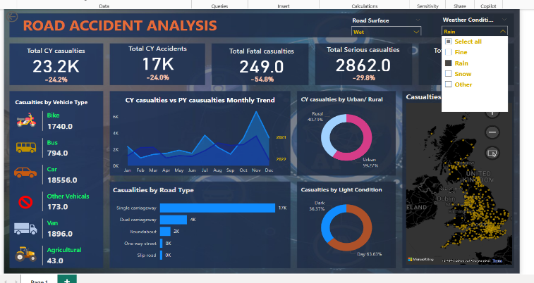

Fig 3: Data Visualization Using Power BI

Acknowledgment
Expresses sincere gratitude to the Ministry of Road Transport and Highways (MoRTH) and Open Government Data (OGD) Platform India for providing access to valuable datasets used in this study. The author also thanks the academic supervisors and peers who provided constructive feedback throughout the research process. Their support played a vital role in the successful completion of this analysis.

References
- Ranjan et al. (2025). "Injury Patterns in Fatal RTAs in Patna City". Journal of Cardiovascular Disease Research.
- IJCRT (2023), M., & Joshi, R. (2023). IoT-Based Smart Traffic and Accident Detection System. International Journal of Creative Research Thoughts, 11(3), 78–85. IJFMR (2022) Kumar, V., & Thakur, N. (2022). GIS-Based Rural Road Accident Mapping in India. International Journal for Multidisciplinary Research, 4(10), 33–45. Ministry of Road Transport and Highways (2022). "Road Accidents in India 2021". MoRTH.
- Verma, K., & Bansal, S. (2021). A Statistical Analysis of Road Accidents in India – Urban vs Rural Trends. International Journal of Research Publication and Reviews, 2(7), 145–152.
- Singh et al. (2022) Singh, D., Yadav, R., & Malik, P. (2022). Impact of Traffic Policy Interventions on Road Accident Trends in India. Indian Journal of Public Policy and Administration, 5(2), 89–97.
- Ministry of Road Transport and Highways (MoRTH). (2017–2022). Road Accidents in India – Annual Reports. Government of India.(datasets)
- OpenCity India. (2022). District-level Road Accident Dataset for India. Open Government Data Platform India.(datasets)
- Kaggle. (2014). Road Accident Data (India, 2001–2014). Retrieved from Kaggle Datasets.

